LANE COLLEGE
JACKSON, TENNESSEE 38301
COURSE SYLLABUS
FOUNDATIONS OF EDUCATION EDU230

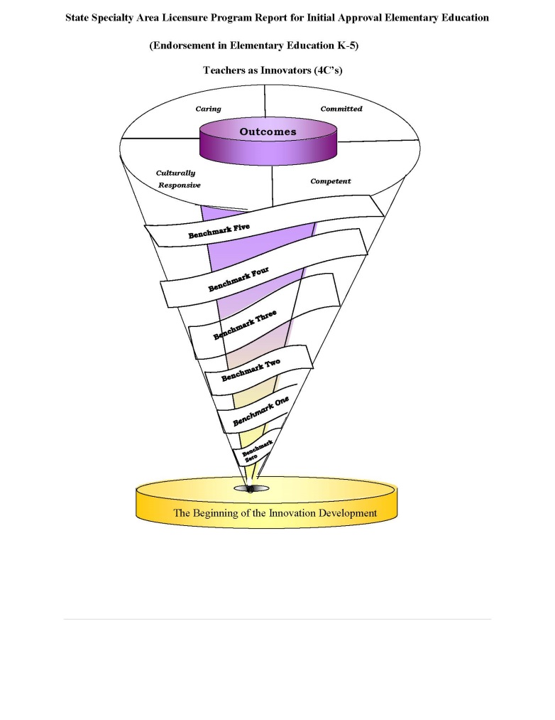
Department of Education

Instructor: Dr. Cell Waller, Assistant Professor

Office Location: Berry Hall 102 Course Meeting Days: T&R 1:00 – 2:15
Office Hours: M-W 10-12, TH 09-12,4-5pm Course Location: Berry Hall
Email: Phone: (901) 489-7540 mobile
Credit hours: 3

Course Description: A study of the historical, social, legal and organizational foundations of American education. Focus is on the distinctive features of American education and the role of African-American educators in teaching African American students. A Christian worldview is integrated throughout all learning experiences.
Required Textbook(s)/Resources
All students are required to purchase the following text:
Ornstein, A., Levine, D., Gutek, G., Vocke, D.Foundations of Education(2014) California: Wadsworth , Cengage Learning.
Vision Statement
The Department of Education is committed to the preparation of 21st century teachers who understand the complexities of learning and teaching that encompass inclusion, equity, and social justice. This work is enhanced by a liberal studies foundation that encourages breadth of knowledge, interdisciplinary and international perspectives, engaged inquiry, and intellectual curiosity. We strive to prepare teacher candidates to possess the 4 C’s; Caring, Committed, Culturally Responsive, Competent and who possess the deep knowledge in their field of study and work collaboratively to achieve high quality education for all.

The organizing theme of the Department of Education is “teachers as innovators”. We strive to help our candidates build and construct new methods, ideas and strategies for meeting the challenging and diverse needs of today’s students.

OVERARCHING UNIT GOALS

Unit Operations Goals
- Meet state and national standards for the Unit.
- Ensure the excellence of all licensure programs in the Unit.
- Respond to the needs of the regional and state-wide teaching community.
Unit Program Goals
- Meet the state and national standards relevant to the various programs.
- Meet the Unit Goals for candidates through the various programs.
- Continue to build strong partnerships with stakeholders.
- Unit Candidate Goals
- Candidates demonstrate knowledge of the depth, breadth, and interdisciplinary connections inherent in the specialty area discipline studied.
- Candidates are knowledgeable of subject matter in order to create meaningful learning experiences for all learners.
- Candidates develop skills necessary for self-reflection and uses this reflection to support student learning and development.
- Candidates demonstrate professional dispositions in varied educational settings with regard to a diversity of students and all members of the school community.

CONCEPTUAL FRAMEWORK
Description of the Conceptual Framework
A graphic schema was constructed to incorporate the department of education’s Conceptual Framework. The six ribbons in the schema symbolize our benchmarks. Each benchmark provides information regarding how our teacher candidates matriculate through the program. The top of the spiral represents the expectations held by faculty that graduates will be caring, committed, competent and culturally responsive urban educators. The faculty uses the acronym 4C’s to refer to the spiral construction model.
21 DOE Proficiencies

Proficiencies are organized into three categories, with proficiencies for committed and culturally responsive educator combined in one category.
(K) Knowledge
(S) Skill

A List of Candidate Proficiencies
A competent educator:
  - demonstrates knowledge of the content that is being taught, and is able to assist students in the process of mastering content through the use of research-based practices; (K)
  - demonstrates the capacity to problem solve, and to think critically and reflectively; (K)
  - demonstrates an understanding of human development, and the ability to act on this understanding; (S)
  - demonstrates an understanding of classroom organization, planning, and management and the ability to act on this understanding; (S)
  - demonstrates an understanding of learning as a socially mediated, constructive process, and the ability to act on that understanding; (S)
  - demonstrates an understanding of effective communication and collaboration strategies; (K)
  - demonstrates an understanding of research, assessment and evaluation as ongoing processes involving multiple sources of information and techniques; (K)
  - demonstrates an understanding of the importance of involving families, communities, and colleagues in the education of all children, and the ability to act on this understanding; and (S)
  - demonstrates knowledge of current technology in educational practice, and the ability to apply it in a classroom or school setting. (S)

A committed and culturally responsive educator:
  - acts on the belief that all children can learn and creates instructional opportunities that adapt to learners from diverse cultural backgrounds and with exceptionalities; (K)
  - demonstrates an understanding of the urgency to accommodate the nature and needs of each learner, and is able to act on this understanding; (S)
  - demonstrates a commitment to high moral and ethical values; and (K)
  - assumes accountability for the outcomes of instruction, and continually validates the effects of his/her choices and actions on others. (S)
  - values and appreciates cultural differences within a classroom or school setting, and is able to apply an understanding of cultural and linguistic diversity to the design and implementation of instruction. (K)

A caring educator (dispositions)
  - understands the right of all students to have access to a curriculum that allows them to develop to their full potential, and is able to act as an advocate for students in this respect;
  - maintains confidentiality;
  - demonstrates appropriate behaviors during class settings and in the work environment. The candidate has been alert and responsive, consistently.
  - demonstrates respect for the profession;
  - demonstrates punctuality in arrival to class, practicum, student teaching, field experience meetings, etc.
  - demonstrates the ability to compromise and to respect others’ opinions during group work;
  - participates in professional development activities that were recommended.

Council for the Accreditation of Educator Preparation (CAEP) Standards

Standard #1: Content and Pedagogical Knowledge
Standard #2: Clinical Partnerships and Practice
Standard #3: Candidate Quality, Recruitment, and Selectivity
Standard #4: Program Impact
Standard #5: Provider Quality Assurance and Continuous Improvement

Interstate Teacher Assessment and Support Consortium (InTASC) Standards

Standard #1: Learner Development
Standard #2: Learning Differences
Standard #3: Learning Environments
Standard #4: Content Knowledge
Standard #5: Application of Content
Standard #6: Assessment
Standard #7: Planning for Instruction
Standard #8: Instructional Strategies
Standard #9: Professional Learning and Ethical Practice
Standard #10: Leadership and Collaboration

Curriculum Alignment to Department, CAEP, InTASC, and Tennessee Standards
COE Proficiencies |  | CAEP Standards | National  Standards  INTASC | Tennessee  Standards  Domains | Student Learning Outcomes | Key  Assessments | Description
During my course work I demonstrated: | S=Skill  K=Knowledge
A Competent educator:  1.demonstrates knowledge of the content that is being taught, and is able to assist students in the process of mastering content through the use of research-based practices; | K | 1 | 4, 5 | I – VI | 1 | Class discussions  Learning activities  Homework assignments  Examinations | Students demonstrate the ability to integrate content from readings and research as evidenced by participation in group, interactive discussions.  Students will participate in classroom learning activities designed to enhance their understanding of course content.  Students will complete problem solving based homework assignments.  Students will demonstrate their understanding of course content through a comprehensive assessment.
2. demonstrates the capacity to problem solve, and to think critically and reflectively; | K | 1 | 5, 7 | V | 1, 4 | Class discussions  Learning activities  Homework assignments | Students demonstrate the ability to integrate content from readings and research as evidenced by participation in group, interactive discussions.  Students will participate in classroom learning activities designed to enhance their understanding of course content.  Students will complete problem solving based homework assignments.
3. demonstrates an understanding of human development, and the ability to act on this understanding; | S | 1 | 1 | VII | 1 | Class discussions  Learning activities  Philosophy Of Education | Students demonstrate the ability to integrate content from readings and research as evidenced by participation in group, interactive discussions.  Students will participate in classroom learning activities designed to enhance their understanding of course content.  Students will compose their educational philosophy.
4. demonstrates an understanding of classroom organization, planning, and management and the ability to act on this understanding; | S | 1 | 3, 7 | VII | 1, 2, 3 | Class discussions  Learning activities  Reflective Journal Paper | Students demonstrate the ability to integrate content from readings and research as evidenced by participation in group, interactive discussions.  Students will participate in classroom learning activities designed to enhance their understanding of course content.  Students will complete a reflective paper.
5. demonstrates an understanding of learning as a socially mediated, constructive process, and the ability to act on that understanding; | S | 1 | 1, 2, 3, 8 | VII | 1, 2, 6 | Class discussions  Reflective Journal Paper | Students demonstrate the ability to integrate content from readings and research as evidenced by participation in group, interactive discussions.  Students will reflect on readings, instructional strategies, and content using a weekly journal.
6. demonstrates an understanding of effective communication and collaboration strategies; | K | 1 | 8, 9, 10 | VII, VIII, IX | 1 | Class discussions  Teaching demonstration  Reflective Journal Paper | Students demonstrate the ability to integrate content from readings and research as evidenced by participation in group, interactive discussions.  Students will present a complete mathematics lesson using instructional strategies comprehended throughout this course.
7. demonstrates an understanding of research, assessment and evaluation as ongoing processes involving multiple sources of information and techniques; | K | 1 | 6, 7, 8 | VIII | 1, 6 | Class discussions  Teaching demonstration  Homework assignments | Students demonstrate the ability to integrate content from readings and research as evidenced by participation in group, interactive discussions.  Students will present a complete mathematics lesson using instructional strategies comprehended throughout this course.  Students will complete problem solving based homework assignments.
8. demonstrates an understanding of the importance of involving families, communities, and colleagues in the education of all children, and the ability to act on this understanding; and | S | 1 | 3, 9, 10 | VII, VIII | 1 | Class discussions  Reflection journal  Philosophy of Education | Students demonstrate the ability to integrate content from readings and research as evidenced by participation in group, interactive discussions.  Students will reflect on readings, instructional strategies, and content using a weekly journal.  Students will compose their educational philosophy.
9. demonstrates knowledge of current technology in educational practice, and the ability to apply it in a classroom or school setting. | S | 1 | 8 | VII | 1, 7 | Class discussions  Teaching demonstration | Students demonstrate the ability to integrate content from readings and research as evidenced by participation in group, interactive discussions.  Students will present a complete mathematics lesson using instructional strategies comprehended throughout this course.
A Committed and Culturally Responsive educator:  10. acts on the belief that all children can learn and creates instructional opportunities that adapt to learners from diverse cultural backgrounds and with exceptionalities; | K | 1 | 1, 2 | VII | 1 | Class discussions  Reflection journal  Philosophy of Education  Community Profile | Students demonstrate the ability to integrate content from readings and research as evidenced by participation in group, interactive discussions.  Students will reflect on their field experiences.  Students will compose their educational philosophy of education.
11. demonstrates an understanding of the urgency to accommodate the nature and needs of each learner, and is able to act on this understanding; | S | 1 | 2, 8 | VII, VIII | 1, 2, 5 | Class discussions | Students demonstrate the ability to integrate content from readings and research as evidenced by participation in group, interactive discussions.
12. demonstrates a commitment to high moral and ethical values; and | K | 1 | 9 | VII, IX | 1 | Class discussions  Reflection Journal  Philosophy of Education | Students demonstrate the ability to integrate content from readings and research as evidenced by participation in group, interactive discussions.  Students will reflect on readings, instructional strategies, and content using a weekly journal.  Students will compose their educational philosophy of education.
13. assumes accountability for the outcomes of instruction, and continually validates the effects of his/her choices and actions on others. | S | 1 | 6, 7, 8 | VII | 1, 2 | Class discussions  Teaching Demonstration | Students demonstrate the ability to integrate content from readings and research as evidenced by participation in group, interactive discussions.  Students will present a complete mathematics lesson using instructional strategies comprehended throughout this course.
14. values and appreciates cultural differences within a classroom or school setting, and is able to apply an understanding of cultural and linguistic diversity to the design and implementation of instruction. | K | 1 | 1, 2, 3, 7, 8 | VII | 1, 5 | Class discussions  Learning activities  Reflection journal  Philosophy of Education  Community Profile | Students demonstrate the ability to integrate content from readings and research as evidenced by participation in group, interactive discussions.  Students will participate in classroom learning activities designed to enhance their understanding of course content.  Students will reflect on their field experiences  Students will compose their educational philosophy.

Brief Description of Graded Assignments
A brief introduction to each of the above listed assignments is below. Detailed descriptions of the major assignments will be provided later in class. In course EDU 230 you will be required to complete and master several Unit and Key Assessments. The Unit assessments are the Perceptional Instrument and Disposition Instrument. The Links from the LCAS system will be provided to you at the beginning of this course.

In addition, the key assessments for this courses are Reflective Journal, Community Profile project, article critique, and Education Philosophy.
Reflective Paper: The purpose of this assessment in your professional preparation is to help you develop the habit of mind of reflecting on how your pedagogical practices impact student learning. You will receive feedback on your self-reflection paper at the end of your field experience(s) and student teaching. Substantive feedback is provided for you to improve your future pedagogical practices as well as your ability to reflect on your teaching.
Community Profile Project: This project is designed for you to examine your school community. It is very important to understand the background of your school, your students and community in which you may teach. Your paper should discuss the population, employment, education, crime, health, transportation facilities/resources and physical environment
Article Critiques: Students will be assigned two article critiques regarding public education, economic inequality, and race in the public schools.
Article Critique Requirements:
- (1) Summary. What is the article about? What is the author trying to communicate to the reader? Be sure to state the author’s main argument and main points. Try to do this in no more than five or six sentences. A good test is showing your summary to somebody who has not read the article; if they read the summary and can tell you what the article is about, you are probably on the right track.
- (2) Praise. What does the article help us understand? What does it clarify for you? Focus on substantive issues (e.g., do not tell me that it easy to read and/or short). Be sure to explain your opinions and use examples from the text to support your claims.
- (3) Critique. Are there things the author does not fully explain? Are big claims unsupported by evidence? Do you disagree with specific claims based upon a different reading of the evidence? Focus on substantive issues (e.g., do not tell me that it is hard to read and/or long). Be sure to explain your opinions and use examples from the text to support your claims
Education Philosophy: You will identify, develop, and refine your beliefs about what teaching and learning entails. These beliefs will likely to shift, grow, and deepen as you gain more experience in the classroom and deepen your knowledge of theory and practice. As we begin this program, we often aspire to something that we are not yet able to do or that we don’t do consistently. This assignment serves as a tool to uncover what we think is best for teaching and learning and whether this is reflected in our actual teaching practice to support the acquisition of new knowledge and reflective examination of your own teaching practice. Your final beliefs statement which will address each of the following prompts:
- I believe that learning…
- I believe that teaching...
- I believe the purpose of schooling is...
- I believe my classroom is...
- I believe all my students are/they learn best when they...
- I believe my students learn best when I...
- My professional goals as a teacher are...
Exams: Students are required to take two exams during the semester, a mid-term exam and the final exam. Please refer to the course schedule for dates.
Course Evaluation
The following list of assignments/activities will be assessed to determine your course grade.

Assignment/Activity | Percentage
Daily Grades/Class Participation (Homework, Weekly Reflection Journals, Learning Activities) | 10%
Attendance | 10%
Reflective Paper | 10%
Community Paper | 10%
Article Critiques | 10%
Teaching Philosophy | 10%
Mid-Term Exam | 20%
Final Exam | 20%

Grades are final once given by the instructor. There are no opportunities for re-doing assignments once they have been completed and turned into the instructor. Extra credit will not be offered. Based on a 100-point scale, final grades will be assigned on the following basis:

Numerical Average | Letter Grade
90 – 100 | A
80 – 89 | B
70 – 79 | C
60 – 69 | D
0 – 59 | F

COURSE POLICES, PROCEDURES, AND EXPECTATIONS

Attendance, Participation, and Professionalism: You must demonstrate the dedication, preparation, and professionalism effective teachers possess. Class attendance, promptness to class, meeting assignment deadlines, preparation for class, group and class participation, and effective use of class time will illustrate this. Attendance is not an option, yet it is a requirement! Notification of absence is required.

- Only approved absences are considered excused. To be considered an excused absence, students will need to provide documentation to the instructor by the end of the second working day following the absence.
- If a student misses more than one fifth of the class time, it will be counted as an absence.
- Submit all assignments on due dates. Late assignments will not be accepted or grades. If a student is ill and cannot attend class on the day an assignment is due, the assignment will be accepted and graded if submitted to the instructor no later than two days after the due date.
- All assignments are required for successful completion of this course.
- If an absence is excused, any quiz, exam or other work (with the exception to the Teaching Demonstration) that contributes to the final grade may be made up through communication with instructor.
- All requirements including reading should be completed before class
- All papers must be typed and double-spaced using 12-point font. Place your name, date, course, and number at the top of the first page.
- All assignments must be turned in on or before the due date. Late assignments will be accepted only if approved by the instructor.
- Cell phone use is not permitted during class instructional time.

Cell Phones: Be Courteous/Considerate. All cell phones must be set to silent during class hours (e.g., No phone calls or text messaging should be conducted during class). If you need to make or receive an urgent phone call or text message during class, then please place your phone on vibrate and quietly step outside of the classroom to complete your call and/or text.

AMERICANS WITH DISABILITIES ACT STATEMENT
Lane College complies with the Americans with Disabilities Act. Students requesting academic accommodations should contact Dr. Michelle Stewart, (Bray Hall Room 306, mcurtain@lanecollege.edu,731-426-7552), in the office of academic affairs. In order to provide accommodations in a timely manner, students are encouraged to contact Dr. Stewart as early in the term as possible.

